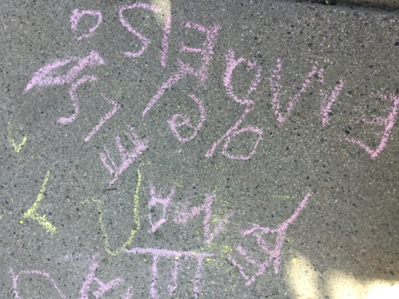

Room 3 Daily Flow

7:30 Center Opens

7:30-9:45 Indoor Activities/Small Group Projects/
Morning Snack (9-9:30)

9:45-10:00 Morning Meeting

10:00-11:20 Outdoor Activities/Gross Motor Experiences

11:20-11:30 Clean up/Transition to Lunch/Song Books

11:30-12:15 Lunch Time

12:15-12:30 Transition to Rest Time (toileting/read books/
switch out masks/small group with Room 3
Teachers’ book collection)

1:00-2:30 Rest Time

2:30-3:00 Transition from Rest Time
(toileting/sunscreen)

3:00-3:30 Afternoon Snack/Indoor Free Play

3:45-4:50 Outdoor Activities

4:50-5:30 Transition Inside/Some Indoor Choices
available/Group time games

5:30 Center Closes

